

Penitration testing

& sEcuring cloud

network

**R0HIT GUPTA**

**PENITRATION TESTING**

**IMPLEMENTING DOS ATTACK ON CLOUD SERVER**

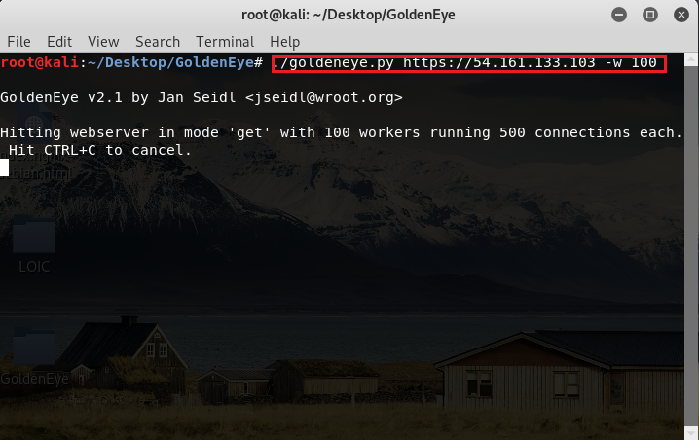

>>After DoS attack

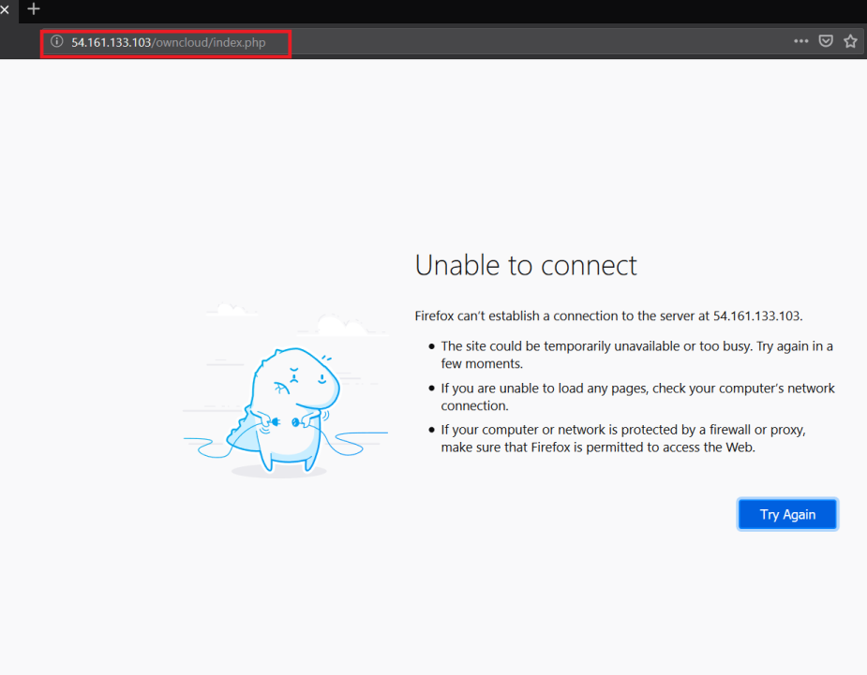

**FINDING VULNERABLITIES AND EXPLOITATION**

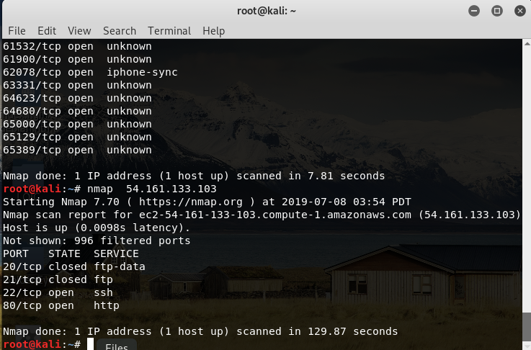

>>Creating Payload

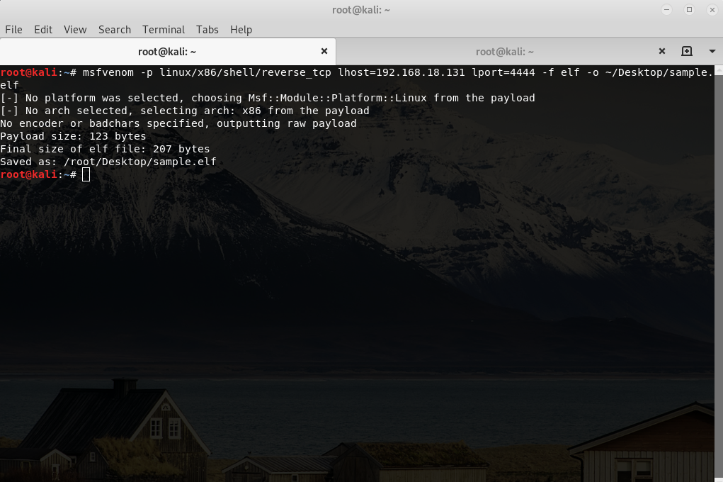

**>>Exploiting Payload**

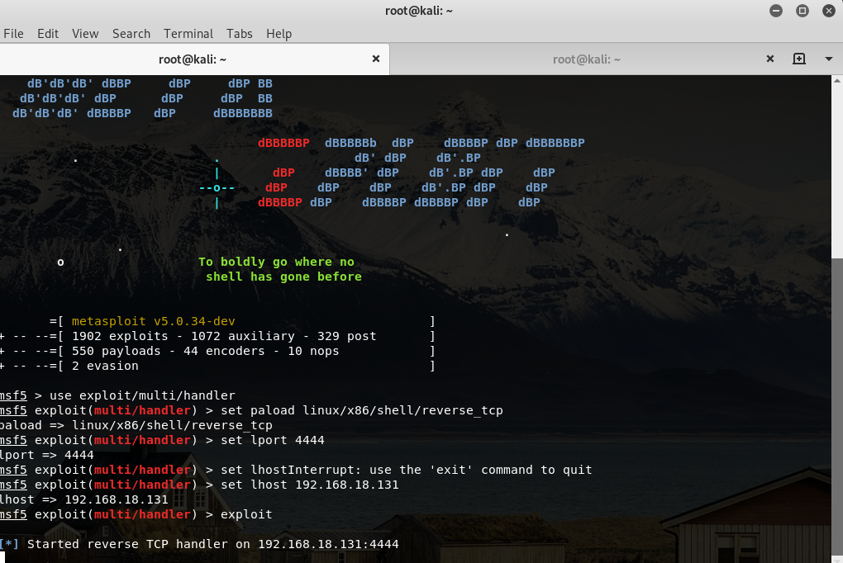

>>Here we tried to find the vulnerabilities on cloud network.

>>We have created payload using MSFVENOM.

>> Try to exploit them using MSFCONSOLE.